**Setup Document**



**Contract** **3**

Agreements: 3

DISCHARGE 4

**Processes** **4**

**Functional requirements** **6**

**GUI** **6**

**Wireframe** **8**

**ERD** **11**

# **Contract**

### Agreements:

**ENGAGEMENT:**

The company(StageBrite) hereby agrees to engage our company(SuMoRyGa Solutions) to provide a software solution for the HighLand Halloween Festival event that will take place. The service shall be provided by (SuMoRyGa) in form of three full-fledged applications namely ; a Desktop application , a website for the users and and an Android Application .

The applications will all take a period of 6 months for completion and delivery upon which any delay (if any) will be communicated to the client 2-3 weeks in advance.

It was also the client’s wish that we run some form of advertisement on the website from which Facebook was identified as a perfect platform from which to run our ads.

The applications will all be only in English since the target audience is mostly foreigners.

The event will go on for 3 days , however its the client’s wish that the applications developed be expandable as he would like to use them for future events of the same kind or so.

Finally a budget was set at 50.000 euros including billables and development work for the applications upon which an extra amount can be discussed should the funds run empty ; however it also holds certain ramifications in the future.

**Engagement Overview:**

1. **Website:**

The website will mainly be used by the event-goers to get information about the

event, consult the schedule, buy tickets, check their balance via a dashboard

dedicated to them(individuals ,groups or VIPs) and cancel their tickets if wished to.

1. **Desktop Application:**

The desktop application will mainly be for sellers at the event , for selling tickets ,

commodities, loan out materials,among others.

1. **Android App:**

This will mainly be for the client to overview revenue.

## **DISCHARGE**

The Formal Client:

I, ………………., the formal client of this project; accept the fact that I have agreed on all of the deliverables1 and on the deadlines1 and confirm that all of the costs and fees will be fully paid by me. I also accept that I will close any other contracts related to this project.

This serves as confirmation that the last and final results have to be transferred to the project agreement.

If there are still any other uncleared details or issues, notify Mr. Mohammed as soon as possible. We appreciate your service and we are looking forward to serving you again. we seek your concurrence!

I, the undersigned, confirm that the above mentioned facts are true and correct and i give the

permission to start the project.

Name: _________________________

Signature:______________________

Date:___________________

The team leader :

I, Mohammed Reza Baghban Haghighi and the rest of the team whose information comes below, accept to deliver all of the required deliverables on time and to use the available budget wisely.

Project Leader:

Mohammad B. H.

------------------------

team members:

Subhi Hamidi Gael Shema Ryan Hermelijn

-------------------- -------------------- ----------------------

# 

------------------------------------------------------------------------------------------------------------

1- As mentioned in the Project plan And Setup Document.

# **Processes**

In the **C# Application**:

In the **website**:

Users will be able to firstly get enough information about the event and the activities and events available.

Since the event will last for 3 days, users will be able to buy ticket based on the number of days they would like to attend the event but also decide between 3 categories of tickets ; Individual ,Individual VIP and a group ticket.

While booking the user must fill in some information about his/her personal details and payment details and for groups, the names and contact information of the participants.

Users will also have a dashboard where they can see their ticket , load balance to their event-account and have a possibility to cancel their ticket plus changing the password of the account.

There will a contact form which will be used under many conditions like requesting of more information or to advertise on the website.

On the bottom of the website there will be a twitter section where it will show what users think about the event using a hashtag.

# **Functional requirements**

|  |  |  |  |  |
| --- | --- | --- | --- | --- |
| Function | Must Have | Should Have | Could Have | Will not have |
| An rfid scanned in order to be granted access to the event. | x |  |  |  |
| When the scanner is toggled on, it will search the database for the rfid number to see if it matches with database. | x |  |  |  |
| Top Up balance by employees | x |  |  |  |
|  |  |  |  |  |
|  |  |  |  |  |
|  |  |  |  |  |
|  |  |  |  |  |

C#

Entrance gate of event

·

· When the scanner is toggled on, it will search the database for the rfid number to see if it matches with one that can enter the event

Entrance camping site

· An rfid must be scanned in order to get to the campsite booked on the account

.

Stores

· The user must click on what he/she wants to buy and add it into a cart

· At checkout, the user must have his rfid scanned to make the transaction

# **GUI**

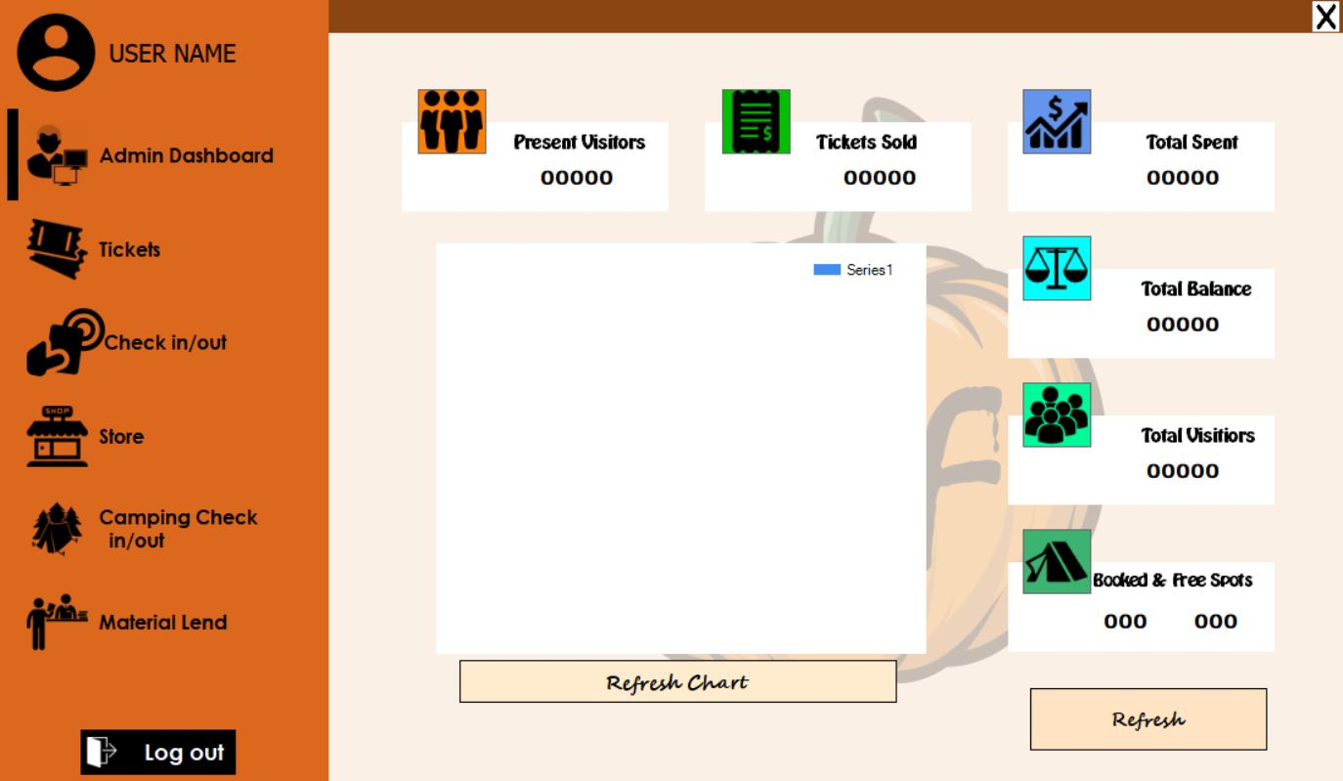

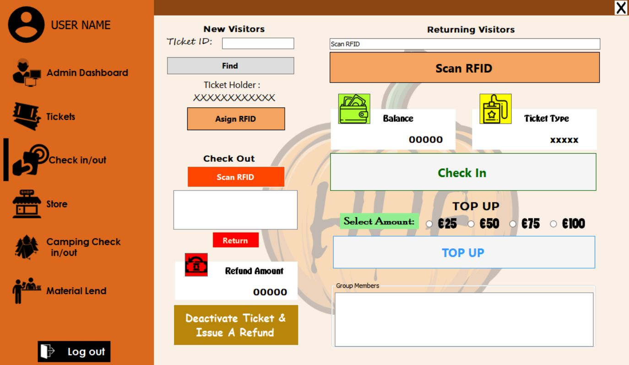

# **Wireframe**

Every wireframe has a brief description below it.

1. Home Page: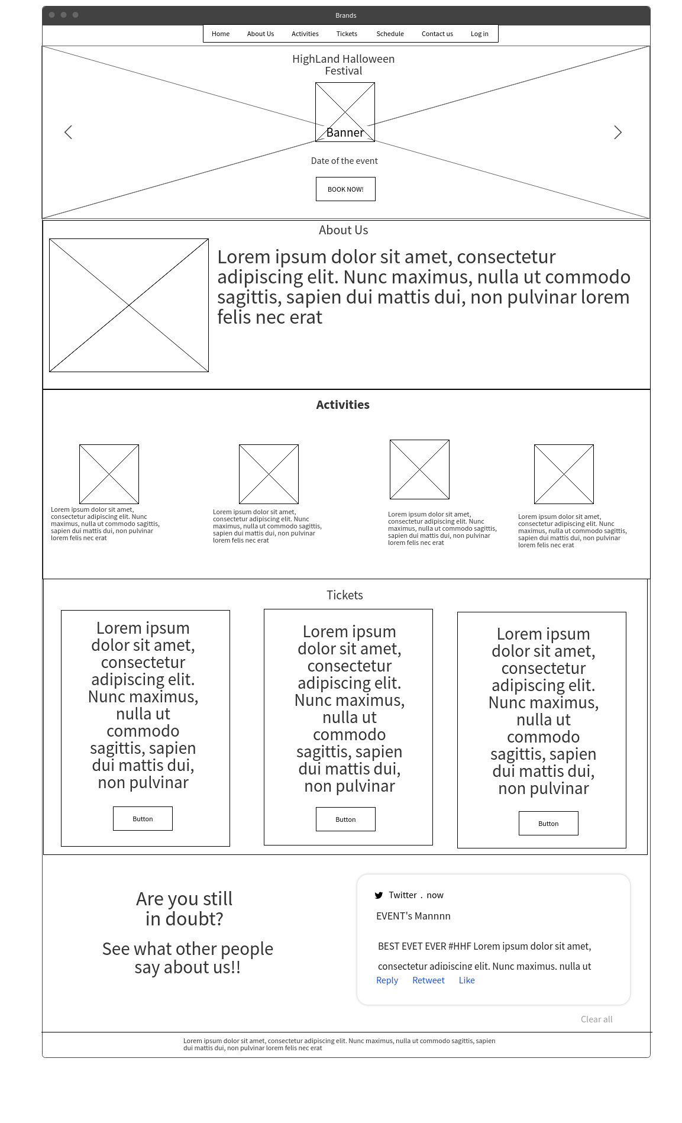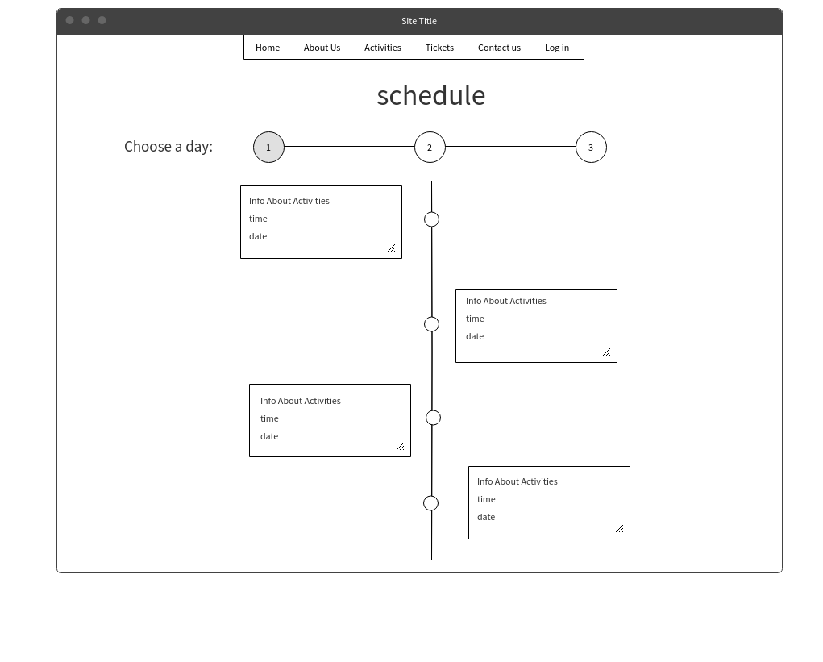

We thought that having the most important information about the event in one page makes it easier for the customers to go through everything by order and at the same time it will confuse the user while browsing the website and it will actually give a general overview of the whole event.

1. Booking form

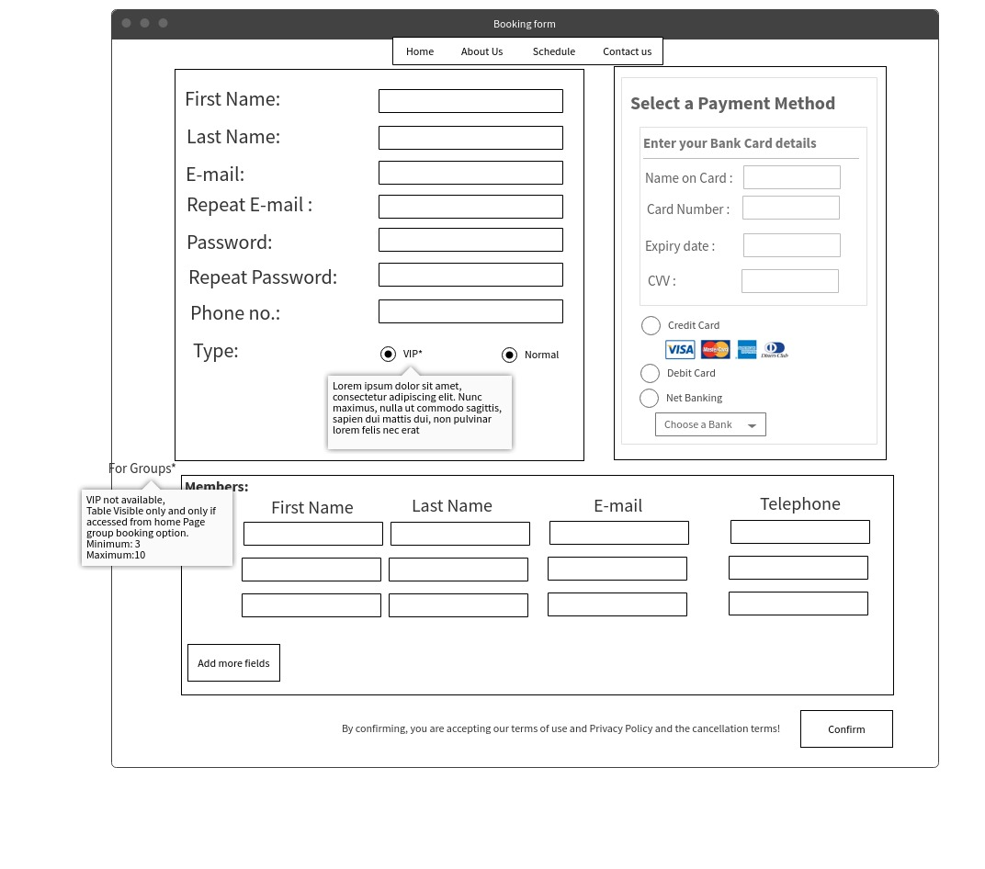

This is more of a self descriptive wireframe, although we will not have the same exact fields of input as in the wireframe but it gives a general idea about the design of the form.

1. Login Page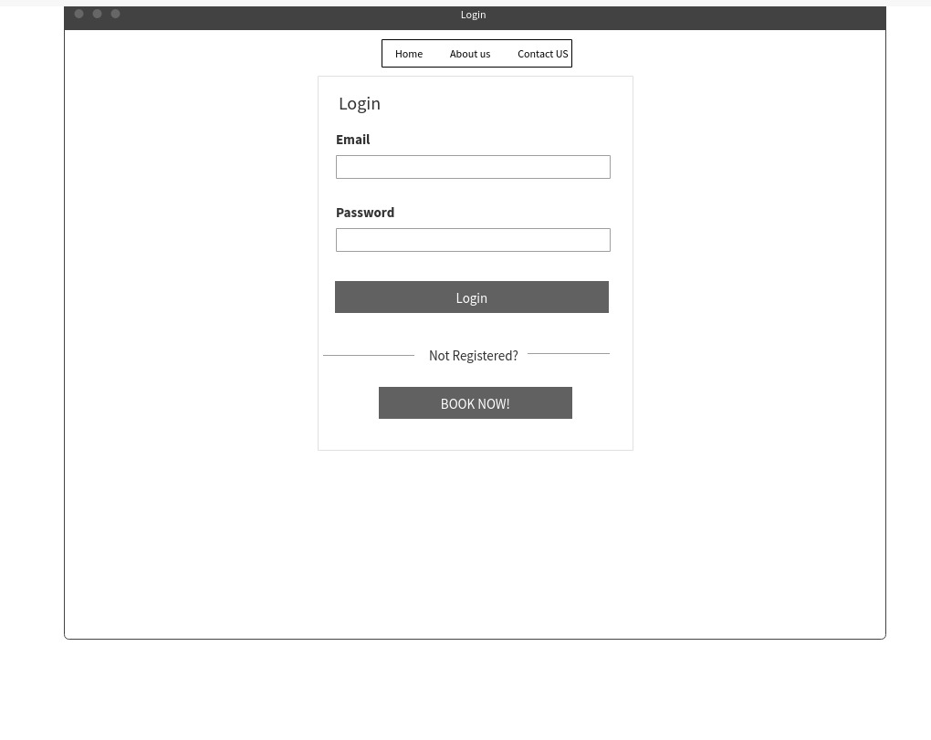

We have decided to use a basic login page with a link to book an event to be actually registered and able to login.

4. Schedule page

This is a Timeline schedule of the event. We thought that this way of showing the schedule will be more comfortable and easier to view to the user.

# **ERD**

